MEASUREMENTS PROJECT
Ntsako K. Manyike
School of Electrical & Information Engineering, University of the Witwatersrand, Private Bag 3, 2050, Johannesburg, South Africa
Abstract:
Key words: Four to six key words in alphabetical order, separated by commas.

Introduction
There is a need for measuring dynamic forces. Dynamic forces can be found in various industrial and research applications such as process monitoring, material testing, motion control, quality assurance and crash testing. Sensors are used in a measurement system to transduce the impact force to an electrical signal that can be manipulated to produce useful information.
Piezoelectric sensors exploit the direct piezoelectric effect to convert a force into an electrical charge. This charge is the input to the instrumentation chain to ultimately produce the measurement of the impact force.

BACKGROUND
One disadvantage of piezoelectric sensors is that they cannot be used for truly static measurements. A static force will result in a fixed amount of charges on the piezoelectric material.

Resistive

Elastic

Pneumatic

Proposed measurement system
Even though piezoelectric sensors are electromechanical systems that react to compression, the sensing elements show almost zero deflection. This is the reason why piezoelectric sensors are so rugged, have an extremely high natural frequency and an excellent linearity over a wide amplitude range. Additionally, piezoelectric technology is insensitive to electromagnetic fields and radiation, enabling measurements under harsh conditions. Some materials used (especially gallium phosphate [2] or tourmaline) have an extreme stability even at high temperature, enabling sensors to have a working range of up to 1000°C. Tourmaline shows pyroelectricity in addition to the piezoelectric effect; this is the ability to generate an electrical signal when the temperature of the crystal changes. This effect is also common to piezoceramic materials.

PRINCIPLE OF OPERATION

The sensor
Piezoelectricity refers to the generation of electric polarity in dielectric crystals when subjected to mechanical stress \cite{Arnau:2004}. The applied stress displaces the anion charges towards the center of the element causing the outer faces of the element to become charged. The element generates a charge that is proportional to the mechanical stress applied. This is called the direct piezoelectric effect which is important when measuring forces.
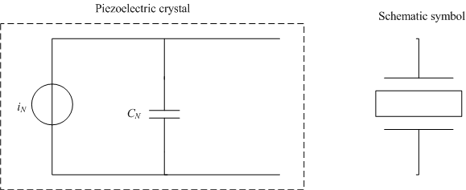
Figure 1: Norton equivalent circuit of sensor
When under stress, the element produces a charge, q, that can be measured by depositing metal electrodes on opposite faces of the element. In this configuration, the element acts like a capacitor in parallel with a current source. The equivalent Norton equivalent circuit is shown in Figure 1 with i_{N} being a current source and C_{N} is due to the capacitor formed by the metallic plates of the element. The magnitude of i_{N} is:
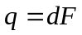 (1)
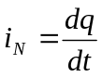 (2)
Where:
d =K/k CN⁻¹ is the charge sensitivity to force.
When a load is connected across the circuit dynamic forces can be measured by measuring the voltage across the load. The electrical path formed by the load allows the capacitor to discharge through the load. From elementary circuits, a capacitor blocks direct current but allows alternating current to pass through. In the circuit in Figure 1, direct current is a constant force while a dynamic force represents an alternating current. This means that constant or slowly varying forces will tend not to cause any current to flow in the circuit while dynamic forces will cause current to flow. This shows that piezoelectric elements are active electrical systems because they only operate effectively when a force is applied to them and they cannot be used for true static measurements \cite{Arnau:2004}.
The time-constant of the element with a load is defined as the time it takes the charge to decrease to approximately 0.37 i_{N(peak)}. The time constant τ is given by τ = R_{Load} x C_{N}.

Errors
System errors: Uncalibrated instrument, Environmental noise, Long term drift.
Internally generated noiselectronically.

SYSTEM MODELLING

System overview
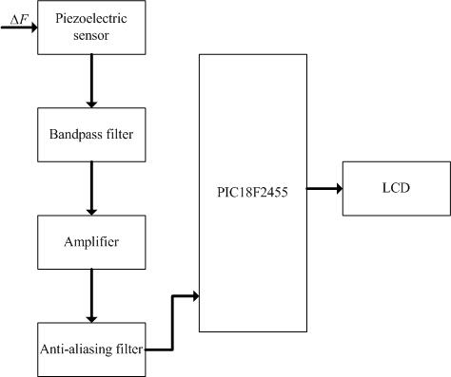

Sensing element
The sensing element is the first element in the measurement system; it is in contact with and draws energy from the impact of the coal with the impact plane \cite{Bentley:2005}. As mentioned previously, a common implementation practice is to sandwich a piezoelectric crystal between two metal plates.
So, piezoelectricity refers to the generation of electricity or of electric polarity in dielectric crystals when subjected to mechanical stress and conversely, the generation of stress in such crystals in response to an applied voltage. A normal output voltages from piezoelectric sensors can vary from microvolts to hundreds of volts, and signal conditioning circuitry requirements vary substantially, and this effect is called direct piezoelectric effect. Hence, when a force is applied on piezoelectric structure, this structure will generate an analog voltage signal between its electrodes. So, based on the value of generated voltage on piezoelectric sensor, the magnitude of applied force is measured.
Piezoelectricity is a linear electromechanical interaction between the mechanical and electrical states of crystals with no symmetric centers.
The piezoelectric effect results from a deformation of the crystal lattice by some external force that pushes the positive and negative lattice points against one another and thus produces a dipole moment. A change of stress in the piezoelectric element produces a temporary potential difference across the element. Attaching two wires across the element one can use this voltage. The resulting formation of an electric field puts an electric potential on the insulated electrodes. This results in a temporary excess of surface charge, which subsequently is manifested as a voltage which is developed across the crystal. In order to utilize this physical principle to make a sensor to measure force, we must be able to measure the surface charge on the crystal. Figure 4 shows a common method of using a piezoelectric crystal to make a force sensor. Two metal plates are used to sandwich the crystal making a capacitor. As mentioned previously, an external force cause a deformation of the crystal results in a charge which is a function of the applied force. In its operating region, a greater force will result in more surface charge. This charge results in a voltage V= Q_{f}/C where Qf is the charge resulting from a force f , and C is the capacitance of the device.
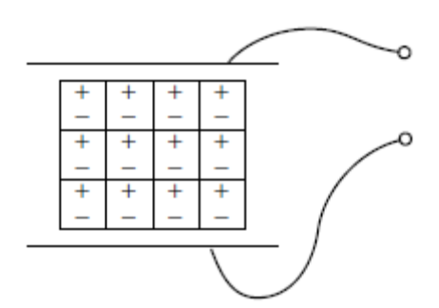
In the manner described above, piezoelectric crystals act as transducers which turn force, or mechanical stress
into electrical charge which in turn can be converted into a voltage.
This is called the receive mode of the sensor. The axes of the crystals can be orientated in three different orientations depending on the force, longitudinal, transverse and shear. The quartz package generates a charge signal, measured in picoCoulombs, that is directly proportional to the sustained force.
For a piezoelectric sensor, output voltage signal is linearly proportional to the applied external force if the piezoelectric material is in elastic deformation.
These piezoelectric devices generate electrical signals only in response to a change in the applied force, since under static stress free carriers drift toward the dipoles, eventually discharging the device \cite{Bentley:2005}.
They are usually the slowest components in the system.
This is the reason why piezoelectric sensors are so rugged, have an extremely high natural frequency and an excellent linearity over a wide amplitude range. Additionally, piezoelectric technology is insensitive to electromagnetic fields and radiation, enabling measurements under harsh conditions.
The single disadvantage of piezoelectric sensors is that they cannot be used for true static measurements. A static force will result in a fixed amount of charges on the piezoelectric material. Working with conventional electronics, not perfect insulating materials, and reduction in internal sensor resistance will result in a constant loss of electrons, yielding an inaccurate signal. Elevated temperatures cause an additional drop in internal resistance; therefore, at higher temperatures, only piezoelectric materials can be used that maintain a high internal resistance.
Transverse effect: A force is applied along a neutral axis and the charges are generated along the d11 direction. The amount of charge depends on the geometrical dimensions of the respective piezoelectric element. When dimensions a, b, c apply:
Cy= -d11 x Fy x b/a
where b is the dimension in line with the neutral axis and a is in line with the charge generating axis.
d11 = piezoelectric coefficient [pC/N]
Fx = applied Force in x-direction [N]
n = number of elements.
The transverse effect opens the possibility to fine tune sensitivity depending on the force applied and the element dimension. Therefore, Piezocryst’s sensors almost exclusively use the transverse effect since it is possible to reproducibly obtain high charge outputs in combination with excellent temperature behaviour.
In both designs, the elements are thin cuboids that are loaded along their longest extension. For pressure sensors, a thin membrane with known dimensions and a massive base is used.
Piezoelectric devices are a very reliable and inexpensive means of converting electrical energy into physical motion and exhibit a high tolerance to environmental factors such as electromagnetic fields and humidity.
Piezoelectric sensors are useful for measurement of force, pressure, acceleration and so on. The advantage of piezoelectric sensors compared with other types of sensors are their long life without aging, high sensitivity, low threshold, wide measuring range, practically displacement-free measurement, high natural frequency and a wide temperature range amongst other things.
Two main groups of materials are used for piezoelectric sensors: piezoelectric ceramics and single crystal materials. The ceramic materials (such as PZT ceramic) have a piezoelectric constant / sensitivity that is roughly two orders of magnitude higher than those of the natural single crystal materials and can be produced by inexpensive sintering processes. The piezoeffect in piezoceramics is "trained", so unfortunately their high sensitivity degrades over time. The degradation is highly correlated with temperature. The less sensitive 'natural' single crystal materials (gallium phosphate, quartz, tourmaline) have a much higher – when carefully handled, almost infinite – long term stability. There are also new single crystal materials commercially available such as Lead Magnesium Niobate-Lead Titanate (PMN-PT). These materials offer greatly improved sensitivity (compared with PZT) but suffer from a lower maximum operating temperature and are currently much more expensive to manufacture.
Based on piezoelectric technology various physical quantities can be measured; the most common are pressure and acceleration. For pressure sensors, a thin membrane and a massive base is used, ensuring that an applied pressure specifically loads the elements in one direction. For accelerometers, a seismic mass is attached to the crystal elements. When the accelerometer experiences a motion, the invariant seismic mass loads the elements according to Newton’s second law of motion F = ma.
The main difference in the working principle between these two cases is the way forces are applied to the sensing elements. In a pressure sensor a thin membrane is used to transfer the force to the elements, while in accelerometers the forces are applied by an attached seismic mass.
Sensors often tend to be sensitive to more than one physical quantity. Pressure sensors show false signal when they are exposed to vibrations. Sophisticated pressure sensors therefore use acceleration compensation elements in addition to the pressure sensing elements. By carefully matching those elements, the acceleration signal (released from the compensation element) is subtracted from the combined signal of pressure and acceleration to derive the true pressure information.
Vibration sensors can also be used to harvest otherwise wasted energy from mechanical vibrations. This is accomplished by using piezoelectric materials to convert mechanical strain into usable electrical energ

Signal conditioning

Signal processing

Data presentation

SYSTEM ANALYSIS

Static characteristics

Dynamic characteristics
Piezoelectric transducer:
Amplifier:
Filter:
Piezoelectric transducer:
Microprocessor
System transfer function:

Conclusion

References
- G.H. Muller and C.F. Landy. “Detection of broken rotor bars, Part 1 – new theory”, SAIEE Transactions, Vol. 95, No. 1, pp. 7-18, March 2003.
- L. Finn, R. Mulholland and G.J. Gibbon. “Design and implementation of a prototype computer based rehabilitation device for the lower extremities”, SAIEE Transactions, Vol. 95, No. 1, pp. 29-32, March 2003.
- P. Vas. “Simulation and monitoring of induction motors with rotor asymmetry”, Proceeding of the 6th International Conference on Electrical Machines, Manchester, pp. 435-439, May 1992.
- A.V. Oppenheim and R.W. Schafer. Discrete-time signal processing, Prentice-Hall Inc., USA, first edition, chapter 3, pp. 82-112, August 1989.

